

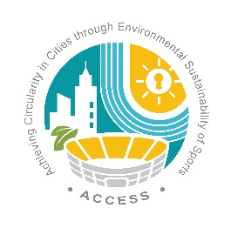


We are committed to championing positive change in our club, for our community and for the planet. Through our club activities, we will unlock the potential of our game to drive positive change for society and the environment.
In support of our commitment to environmental sustainability, we will:
- Assess our operations and processes and identify opportunities to improve our environmental management
- Embed sustainability into our planning and decision-making, aligning it with the priorities of our local and regional authorities.
- Engage our club members and supporters in sustainability awareness and initiatives.
- Regularly communicate our sustainability actions to our members and supporters.
- Ensure our sustainability activities and projects are designed to be inclusive for club members of all backgrounds and abilities.
- Support the sustainability strategy of the Football Association of Wales.
- Align our activities with the UN Sustainable Development Goals, recognising that tackling climate change and environmental degradation goes hand in hand with improving health and education, reducing inequality, and spurring economic growth.

Our club has committed to implementing the two specific Green Goals of:

1.

2.

Signed: [Club Chairperson or equivalent]:


Date:

